Detailed Example
Example 1: Allergy Detection from Ingredient Label
Before meal suggestions are created, the user uploads the input of ingredient words from a food label to automatically identify possible allergies.
Input:
AI Processing:
- Detects shrimp $→$ shellfish
- Detects lemon $→$ citrus
- Citrus implies fruit by default.
Detected Allergies Output:
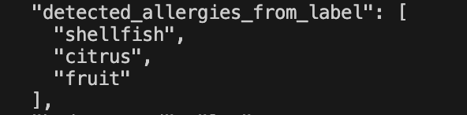
Result:
Meals with fish, shellfish, citrus, or fruit-related tags are avoided, ensuring that the user is not directed to meals that may cause allergic reactions.
Example 2: Fruit Allergy
During profile setting, the user specifically indicates a fruit allergy to avoid being exposed to any fruit-based items.
Input:

AI Processing:
- Uses ALLERGY_MAP[“fruit”]
- Meals with tags such as contains_fruit, contains_apple, contains_strawberry, and so on are excluded.
Then, the output:
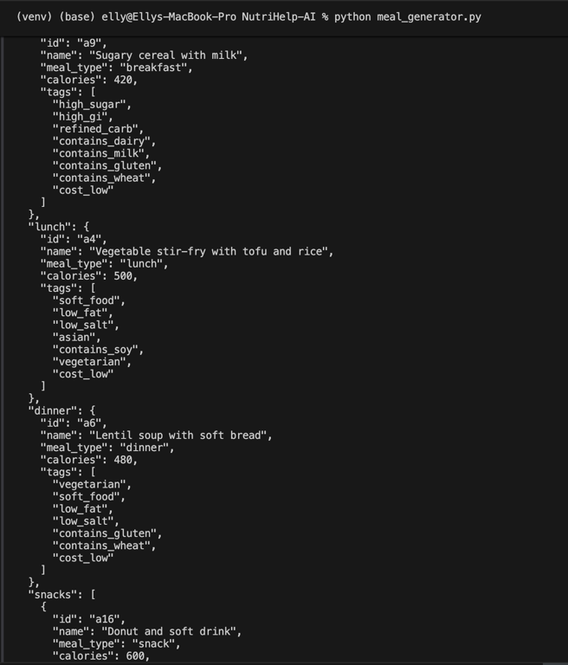
Result:
All fruit-based snacks and meals have been completely removed from the recommendation pool, boosting dietary safety.
Example 3: Nut Allergy
The user claims a generic nut allergy without specifying the type of nuts involved.
Input:
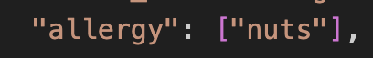
AI Processing:
Nuts maps to:
- Contains_nuts
- Contains_tree_nut
- Contains_peanut

Output:
To ensure total allergy protection, all nut-based foods, including peanuts and tree nuts, are avoided.

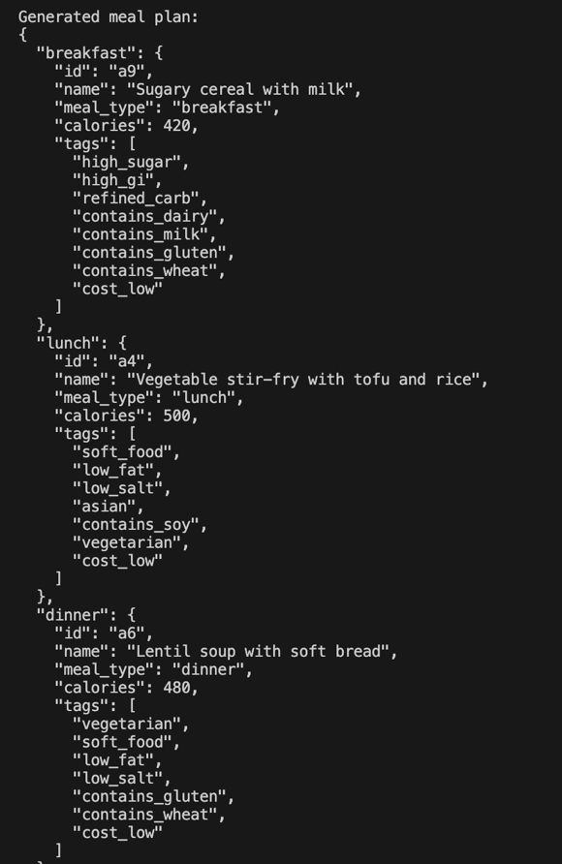
Result:
Meals that contain nuts, such as peanuts and tree nuts, are not included.
Example 4: Health Condition – Diabetes
The user has diabetes and seeks meal suggestions that avoid high sugar and high glycemic items.
Inputs:

AI Processing:
- Uses CONDITION_MAP[“diabetes”]
- Exclude meals with tags:
- High_sugar
- High_gi
- Refind_carb
- Dessert
Output:
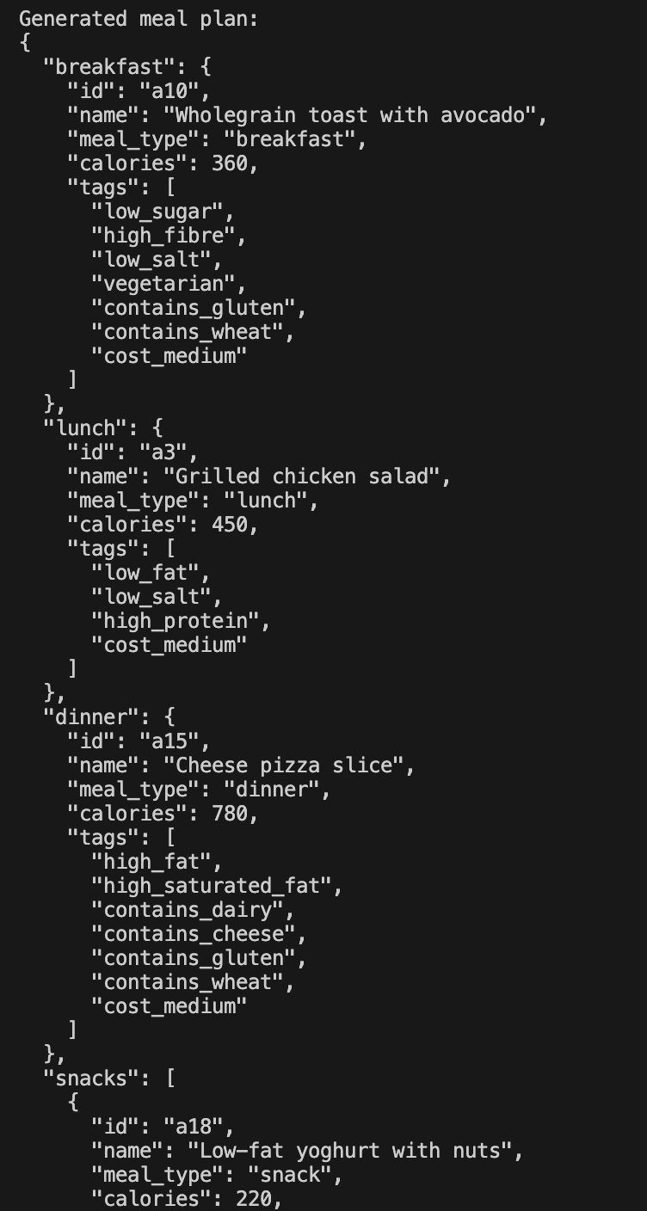
Result:
Only meals suitable for diabetics are considered.
Example 5: Older People Who Need Soft Food
For safety and comfort, the user, who is elderly, needs meals that are simple to chew and swallow.
Input:
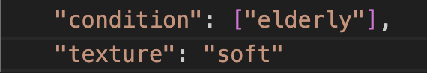
AI Processing:
- Filters meals with the soft_food tag.
- Avoid rough, crunchy, or hard foods.
Output:
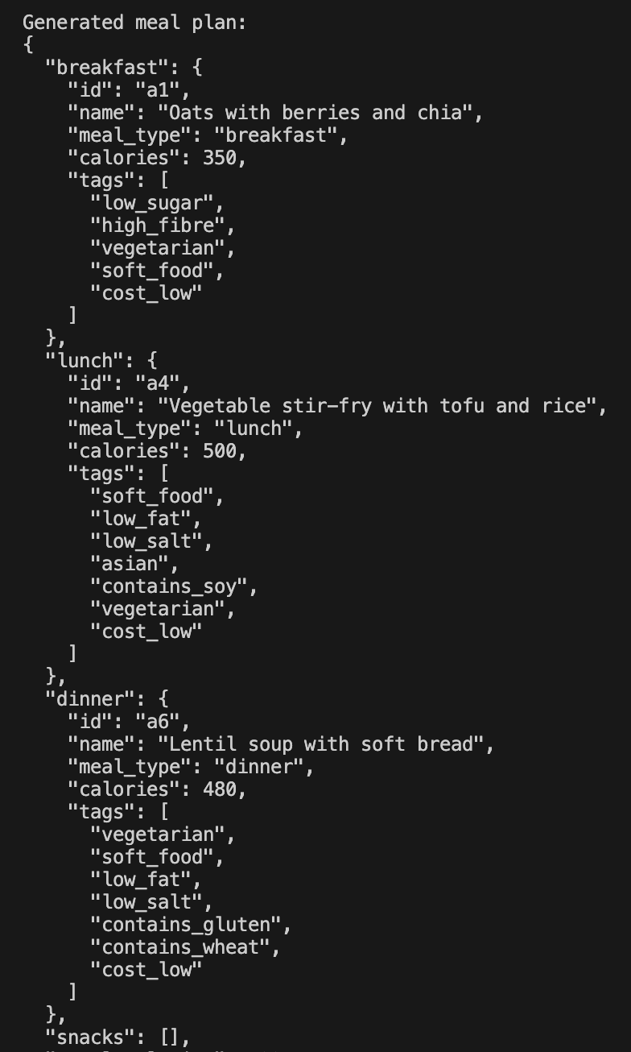
Result:
Safety, accessibility, and convenience of consumption for elderly people are given top priority in the meal plan.
Example 6: Budget-Constrained User (Fallback Logic)
The user has a limited budget and needs reasonably priced food options.
Input:

AI processing:
- Tries meals with the cost_low tag.
- If none are found, cost_medium is used instead.
- Includes all meals as a last resort.
Output:
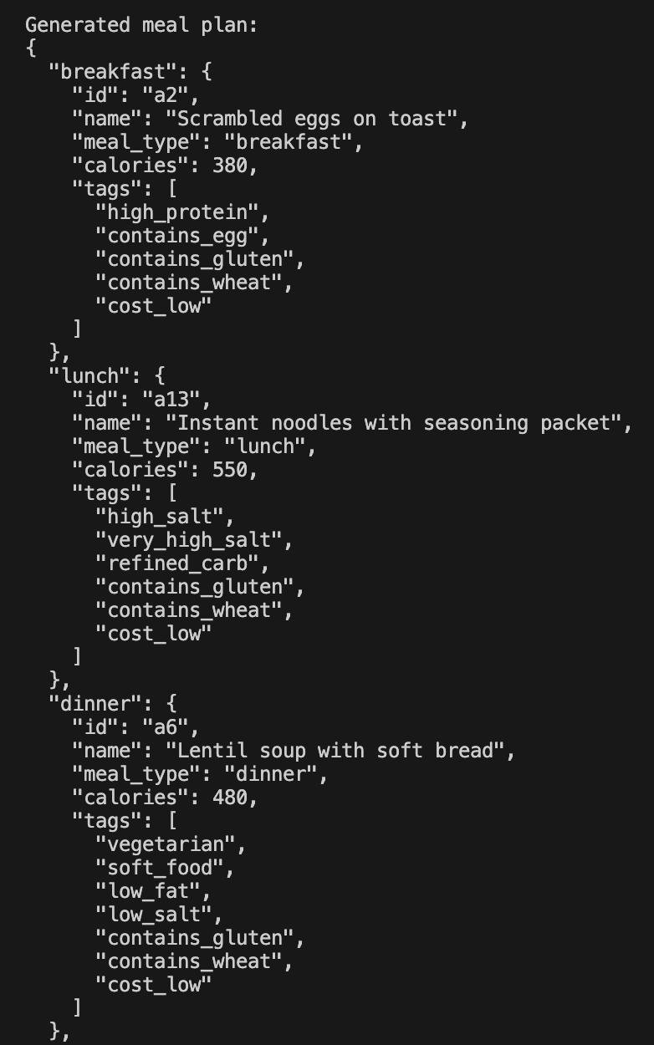
Result:
Despite having few alternatives, the system always generates a meal plan.
Example: 7: Full End-to-End Meal Plan Generation
The user has several limitations, including a health condition, a limited budget, and allergies identified from labels.
Input:
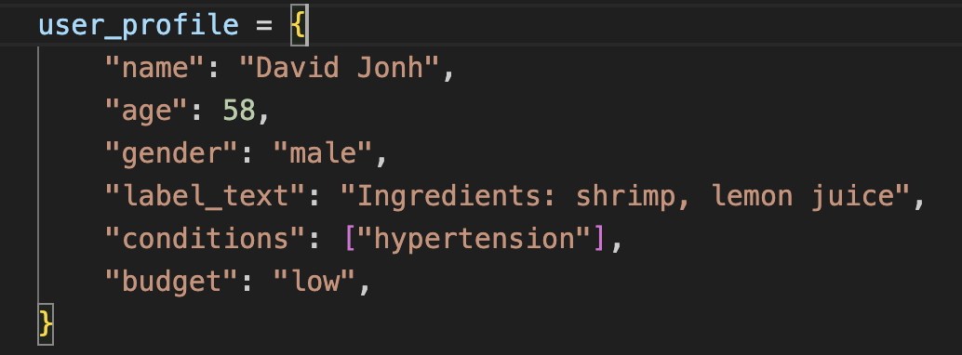
AI Output:
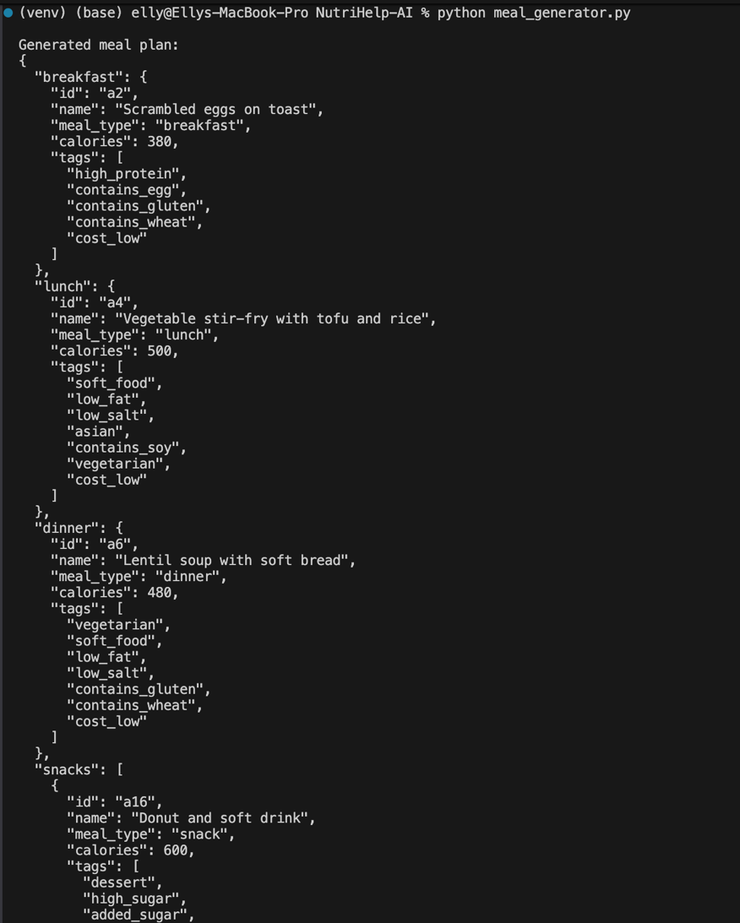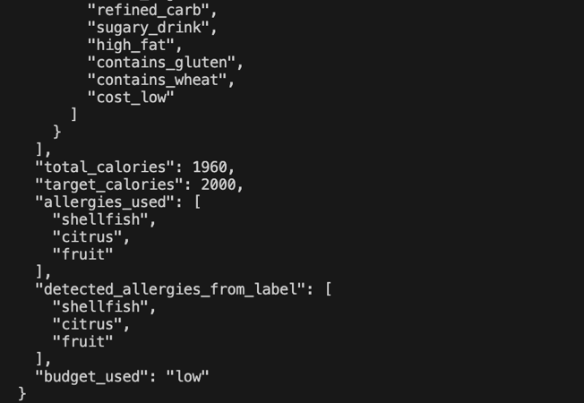
Result:
A daily food plan that is safe, cost-effective, and healthy is created while considering any user limitations.
Conclusion:
The example shows how the NutriHelp AI system uses a structured rule-based approach to provide safe, customized, and understandable meal recommendations. The system efficiently handles actual dietary restrictions by combining user input, ingredient label analysis, and well-defined allergy and health condition regulations. Strict filtering methods prioritize safety, and backup logic makes sure that, in situations where options are few, valid meal plans can still be created. Overall, the modular structure supports transparency, reliability, and easy expansion for potential AI improvements in succeeding trimesters.

